**SIMPLE GUIDE: HOW TO USE ZOOM**

**WHAT IS ZOOM?**

Zoom is a computer program used to hold online “virtual meetings.” You can use Zoom on a smartphone, a tablet, a laptop, or a desktop computer. It uses your computer’s or phone’s camera to show live video of you to all attendees, and your computer’s or phone’s mic and speaker to let you hear and talk to other meeting participants.

**If you do not have access** to a device that has a microphone and camera, you can use a phone to dial into a meeting. You will be able to hear and be heard, but of course you won’t see or be seen. See “Accessing Zoom Two Ways” on page 6 for more sophisticated options in that case.

A Zoom account is not required if you are joining Zoom meetings as a participant. If someone invites you to their meeting, you can join as a participant without creating an account. Just click on the link provided in the invitation.

However, if you are joining using a tablet or smartphone, you’ll need to have downloaded the Zoom app ahead of time—see page 6, “Downloading the Zoom App” (don’t worry—it’s easy and it’s free!).

**HOW TO JOIN A MEETING**

*You’ll have received an email invitation—****hold on to it!***

*You may need to copy**the meeting’s code and password again.*

**If you are using a computer** (desktop or laptop): You’ll have received an email invitation to a Zoom meeting. At the time the meeting is scheduled to start, click the hyperlink that says, “Join Zoom Meeting.” The hyperlink looks like a long underlined list of letters and numbers, usually in blue type. If clicking on the link doesn’t work, copy the string of letters and numbers into your internet browser.

**If you are using a tablet or phone** (smartphone or otherwise): On a tablet or smartphone, assuming you’ve already downloaded the Zoom app, tap that app’s icon if tapping the hyperlink in the invitation doesn’t work; and if you have trouble with that or if you are using a non-smart phone: The invitation will include a choice of phone numbers for dialing in. Dial a number close to your geographic location or a toll-free number provided. Enter the meeting’s code and possibly a numerical password; these will be included in your invitation.

**HOW TO PARTICIPATE IN A ZOOM MEETING**

You will now see a window that says “Join a Meeting.“ It may ask you to put in the name you’d like to have associated with your video, and it may ask you whether you want to join with video and/or join with audio. If you join with video, you will see your image before you enter the meeting.

**Note:** Position the camera on your device (desktop, laptop, tablet, or phone) to make your whole face visible. You may need additional light in the room, if your image is too dark.

You will be automatically placed in a “waiting room,” and we will check your name off the list and admit you.

Once you’ve joined the meeting, you will see and hear other participants. Each participant is represented by a rectangle that displays her face with her name on the bottom, in small white letters (Number1 on the photo below). Those without cameras, or who are camera shy, will be seen as black rectangles with their names.

**Names:** For our reunion, it’s important that everyone recognize you, and you may look very different from your yearbook photo! Please “Rename” yourself to include the name we knew at Hunter if necessary:

|  |  |
| --- | --- |
|  | Move your cursor to the upper right corner of your rectangle. A blue button that says Mute or Unmute appears, and next to it a blue oval with three dots (2). (If your cursor looks like a hand when you’re on the dots, move it out of the area and back in—it has to look like an arrow for you to be able to click.)  Click on the three dots, and a list of options drops down.  Click on “Rename” (3), and in the box that opens up, enter your name including maiden name; then hit “Enter.” |

By the way, about those three dots: On many apps and program windows, you may see three dots, either horizontal as here or stacked vertically; or you may see three stacked horizontal lines. If you click on those buttons, you get lists (called “menus”) of useful (or sometimes not so useful . . .) options. Play with it!

**VIEWS:**

If your screen looks like the one below, the arrangement is called **Gallery View**: all the participants are shown in equal size.

The person who is speaking automatically has a yellow outline around their box—shown below in the left column, second person down.

|  |  |
| --- | --- |
|  | **Note** the black rectangle on the lower right with the name Malynda Rascoe. She has opted to participate but has not removed the red line from the video icon. She can participate and be heard, but we cannot see her. When she speaks, her box will be outlined in yellow even though she’s not visible herself. |

Your Zoom window may open up looking like the above, or it may open showing the speaker’s face occupying most of the window, perhaps with participants in small boxes arranged around the speaker. This is called **Speaker View.**

You can change from one View to the other:

Place your cursor on the black strip in the upper right corner of the Zoom window. A button or buttons appear: depending on your system, you may see one that says “View” (left image), which you can click on to get View choices, or you may see the choices as separate buttons (right).

or 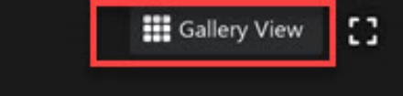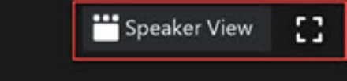

Click on the View that you feel most comfortable with.

In the left picture above, notice that above “View” there are three other symbols. The rightmost one (X) is used to quit out of a window altogether. That closes that program or document completely. The left one (—) minimizes the window so it’s invisible but not closed: If you click on its icon in your status bar (the bar usually at the bottom of your screen showing various apps and programs you have open), you’ll either open it directly or get a graphic of various open programs from which to choose—click on the one you want to open.

The middle icon, which looks like a square here: As a single square, it tells you your window is reduced (it doesn’t fill the screen). Click on it, and it turns into a double square and your window fills the screen. Click again to reduce.

**KEY TOOLS**

To be seen and heard, and to communicate, you need to be familiar with the use of these key tools:

Move your cursor to the bottom black strip of your Zoom screen. Several labeled icons appear. The Microphone and Video tools are located in lower left corner:

**🡩 🡩**

**Microphone:** This icon looks like a little microphone. It controls your being heard.

If the microphone has a red line through it, you are “muted” (no one can hear you). Click on it (unmute) if you want to talk during the meeting. Click on it again to mute yourself. The host is able to mute you.

If someone is muted, you’ll see the crossed-out microphone in the lower left corner of her rectangle.

**Video:** The icon looks like a small movie camera. This controls your picture.

If there is a red line through it, no one will see you, just your name in a black rectangle. Click on the icon, the red line will disappear, and people can see you (you’ll see yourself in your named rectangle). Click again to become just a name.

Typically, during a meeting with many participants, the host will mute everyone (you’ll see a red line through your microphone), to reduce distracting noises that can be picked up by your mic at home (like a ringing telephone). When you wish to speak, **Raise your Hand** (see Reactions on page 5) and the host will call on you and unmute your microphone, then mute it once again when you have finished speaking.

**CLOSED CAPTIONING:**

|  |  |
| --- | --- |
| **🡩** | For those who have hearing issues: In the central group of icons at the bottom of your screen there will be a button marked **CC** and labeled **Live Transcript** or **Closed Captions**. Click on that and a menu appears; click on “Show Captions” or similar wording. If you click on “Settings,” you can change the appearance of your captions. |

**PARTICIPANTS**

|  |  |
| --- | --- |
|  | Typically, a meeting will show as many as 25 people on one screen. Check out the icon marked **Participants** on the center bottom of the screen. It will tell you how many are present. If there are more than 25, move your cursor to the center of the right edge. An arrow appears in a blue field; below that you’ll see an indicator of which screen you’re seeing: This one says 1/2, meaning this is the first of two screens. Click on the arrow to get to the next screen, to view additional groups of participants. To go back to the first screen, put your cursor on the leftedge and click the arrow that appears there.  (Sometimes the rectangles play Musical Chairs: Don’t be surprised if people get rearranged!)  If you click on the Participants icon, a list of names of all the participants will appear next to the Zoom window or in the Chat box. |

**CHAT**

|  |  |  |
| --- | --- | --- |
| To the right of the Participants icon is the **Chat** function. Click to open the **Chat**, as often there are written side communications during a meeting. A window may open to the right of your screen, like this: |  | |
| or it will appear in the middle of your Zoom window, like this:  If it’s in the middle of your window, you can put it elsewhere on your screen (see “Moving Windows Around” instructions at the end of this document). | |  |

Participants can address Everyone or a specific participant. Type your message in the box at the bottom of the Chat window after selecting the recipient in the “To” box; hit Enter, and the message can be seen, along with the name of the person who posted it. It is not private, so be advised.

Ignore the **“Share Screen”** icon—you won’t be using it at our reunion.

**REACTION**

On the center bottom bar toward the right is the **Reaction** icon, where you can place a thumbs-up icon or other emojis on your rectangle. In some systems, this is also where you find the **Raise Hand** icon—other systems have that as a separate icon, either on the bottom of the window near Reaction or in the Chat or Participants window. This is important if you wish to be recognized by the host, especially for a more formal discussion, so people aren’t trying to all talk at the same time. If you can’t find the **Raise Hand** icon, you can write something like “I’m raising my hand” in the Chat. You can also just raise your hand for the camera, but in a larger meeting, the host might not see you.

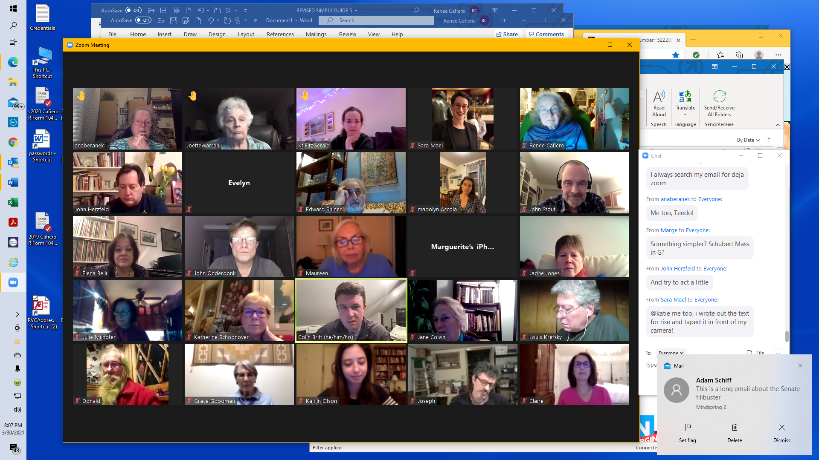 Notice the little Raised Hand in the upper left corner.

When you’ve had your say, please remember to click Raise Hand again so it disappears from your rectangle.

**BREAKOUT ROOMS**

During our Reunion there will be a time when we break up into smaller groups, to discuss different topics of interest. These are known as **Breakout Rooms**. We’ll have three 15-minute breakout sessions, so you’ll be able to select three different topics (out of five or six) to explore with our classmates.

|  |  |
| --- | --- |
| When the host announces that it’s time to go into breakout session, you’ll see an icon in the center bottom group.    **🡩** | A new menu pops up, showing the choices of topics; click on the room you’d like to join.    At the end of the first breakout session you’ll get a blue **Leave Room** from the host; click on that to get back to the main room, and you’ll then get to choose a second and third breakout session.  Note that **Closed Caption** is available only in the main room, so those who want it will have a topic there and won’t move to a different room. |

**TO EXIT AND LEAVE ZOOM**

At the lower right corner is the red button **Leave.** Click it when you want to leave the meeting.

A second **Leave Meeting** will pop up for you to click, confirming your choice.

By the way, if you’re having any problems with your video or audio, it sometimes helps to Leave the Zoom meeting and come right back in, starting from scratch. (**You did save the email invitation with the hyperlink, meeting code, and password, right?)**

**FOR THE MORE ADVENTUROUS:**

**Downloading the Zoom App:**

|  |  |
| --- | --- |
| Your tablet or smartphone, whether Apple or android, comes equipped with an “app store” icon. It may be called Play Store or similar. Tap on that icon. | **or** |

At the top of your screen a Search window (it may show a magnifying glass) opens. Type the word Zoom into that window and Enter. You may get a choice of Zoom programs—“Zoom Cloud meetings” or “Zoom for Meetings” is what you want. Tap on your choice, and when the next window comes up, tap “Install.” This will take a few minutes; it will show you that it’s working on installing the program, and when it’s finished, the button marked “Open” will fill in for you to tap.

For Apple products, you’ll need to put in your Apple ID; androids don’t ask for a password.

Tap on the Open button to make sure it’s installed; you can then close out of the app and the app store until meeting time.

|  |  |
| --- | --- |
| Now when you want to join a Zoom meeting, either tap on the link in the invitation or tap on the Zoom icon on your phone/tablet screen and enter the meeting’s code and password. |  |

**Accessing Zoom Two Ways:** If your computer doesn’t have a mic and camera, and you have a smartphone but you find the screen too small for looking at everyone (or your phone isn’t a smartphone), you can use your phone and computer together: Connect to the Zoom meeting with your computer so you can see the meeting on your computer screen, but also join with your phone; if it’s a smartphone, you’ll likely see the speaker and nobody else. If it’s not a smartphone, you’ll still be able to hear and be heard.

**Important:** When accessing by two different devices, to avoid ear-painful feedback, choose to connect with the audio on your phone and turn off the sound on your computer.

**Chatting to a Single Person:** If you put your cursor in someone else’s rectangle at the upper right corner, you’ll see a blue oval with three dots. This gives you a few options vis-à-vis that person, including “Chat.” If you click on that, the “To” box at the bottom of the Chat shows that person’s name, so you can send a private message. (But note that if the Zoom session is recorded, your message will be saved, so it’s not entirely private.)

Once you’ve sent your message, you’ll want to change the “To” box back to Everyone, so you can send general comments to the whole group. Put your cursor in he “To” box, and a list of recipients appears, with Everyone at the top—click on that to put it in the box.

**Moving Windows Around:** Move the cursor to the top strip of a window, to a spot where there are no icons. Hold down the mouse button and move the cursor to where you want to place the window. This is called “dragging.”

**Screen Size:** If your Zoom screen is filling your computer screen and you want to reduce the size, press “Esc” to make the Zoom screen a smaller window; then you can see any other open windows on the rest of your screen. (Great for multitasking!)

**Sizing Windows:** If your window isn’t a convenient size (too small: material at the bottom or edges is cut off; or too big: lots of white space and taking up too much room), you can easily change it.

Place your cursor on the side edge or bottom edge of the window so a double-sided arrow appears. Hold down the mouse button and drag the cursor inward or outward to the size that you’re comfortable with.

You can also put the cursor on a corner of the window and drag it diagonally, to change both the height and width simultaneously.

**Going Further:**

Now that you’ve seen how easy it is, maybe you want to do more Zooming and even invite people to your own meetings. For that, you’ll need to set up a Zoom account:

1. Type zoom.us into your browser (you don’t need www.; do not add .com).

2. Click the button in the upper right hand corner that reads **Sign up, its free**.

3. Type in your email address or sign up with your Google or Facebook account.

4. It will then send an email with a confirmation link. Click on the link in the email.

5. Create your account by filling in the information it asks for.

6. Skip the **invite colleagues** step. Fill out prompts.

7. Click **go to my account**.

Here is a **tutorial** with all the steps for using Zoom: [A Step-by-Step Guide to a Zoom Meeting | Seniors Guide](https://www.seniorsguide.com/technology/a-step-by-step-guide-to-a-zoom-meeting/) (click anywhere on the underlined words; if that doesn’t work, hold down Ctrl and then click; and if that doesn’t work, copy [https://www.seniorsguide.com/technology/a-step-by-step-guide-to-a-zoom-meeting](https://www.seniorsguide.com/technology/a-step-by-step-guide-to-a-zoom-meeting/) Into your browser.

After about a paragraph and a half below the photo, there’s a **Read More** button. Click on that for the step-by-step instructions.

If you prefer a different tutorial or more advanced ideas, google “Zoom tutorial” and you will find dozens.

There are many other functions in Zoom that we haven’t touched on—backgrounds (you can choose a photo of your favorite beach instead of your messy kitchen to be sitting in) and filters (remember the lawyer who couldn’t stop being a kitten?), for one. You may notice that some people have replaced their video with a photo of themselves. And there’s screen sharing, too. Explore Zoom on your own!